|  |  |  |  |  |  |
| --- | --- | --- | --- | --- | --- |
| Date | 28-Nov-22 | | | Tester Name | Mayuri Patel |
| Environment | Penfax - Test | | | Login used |  |
| Operating System | Windows | Version: | Update: | | |
| Software Used | Edge | Version: | Update: | | |
| Not Applicable | Version: | Update: | | |
| Release version | 22.4.1 | | | | |
| Title | Death | | | | |
| Test Type | Regression | | | | |
| Test Scenario | Process a death payout to a spouse in cash | | | | |
|  |  | | | | |
| Expected Results | Deceased member’s investment account should have $0 after death payout is processed.  Benefit Receipt should be generated under beneficiary’s account.  PEPP Payment to Non-Member letter and Tax Slip should be generated for beneficiary. | | | | |
| Pass/Fail | Pass | | | JIRA# | N/A |

Describe your steps with screenshots:

1. In PENFAX5 do a search for the deferred survivor member. Click on the stakeholder ID.

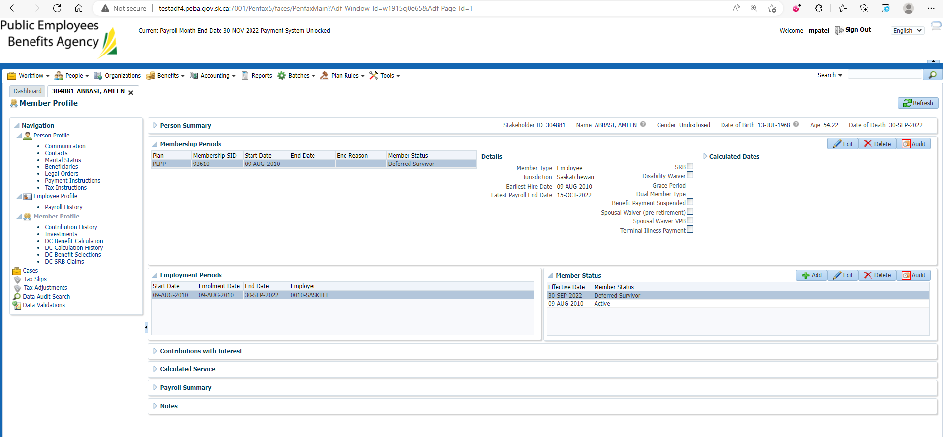

1. Click DC Benefit Selection. Click Add.

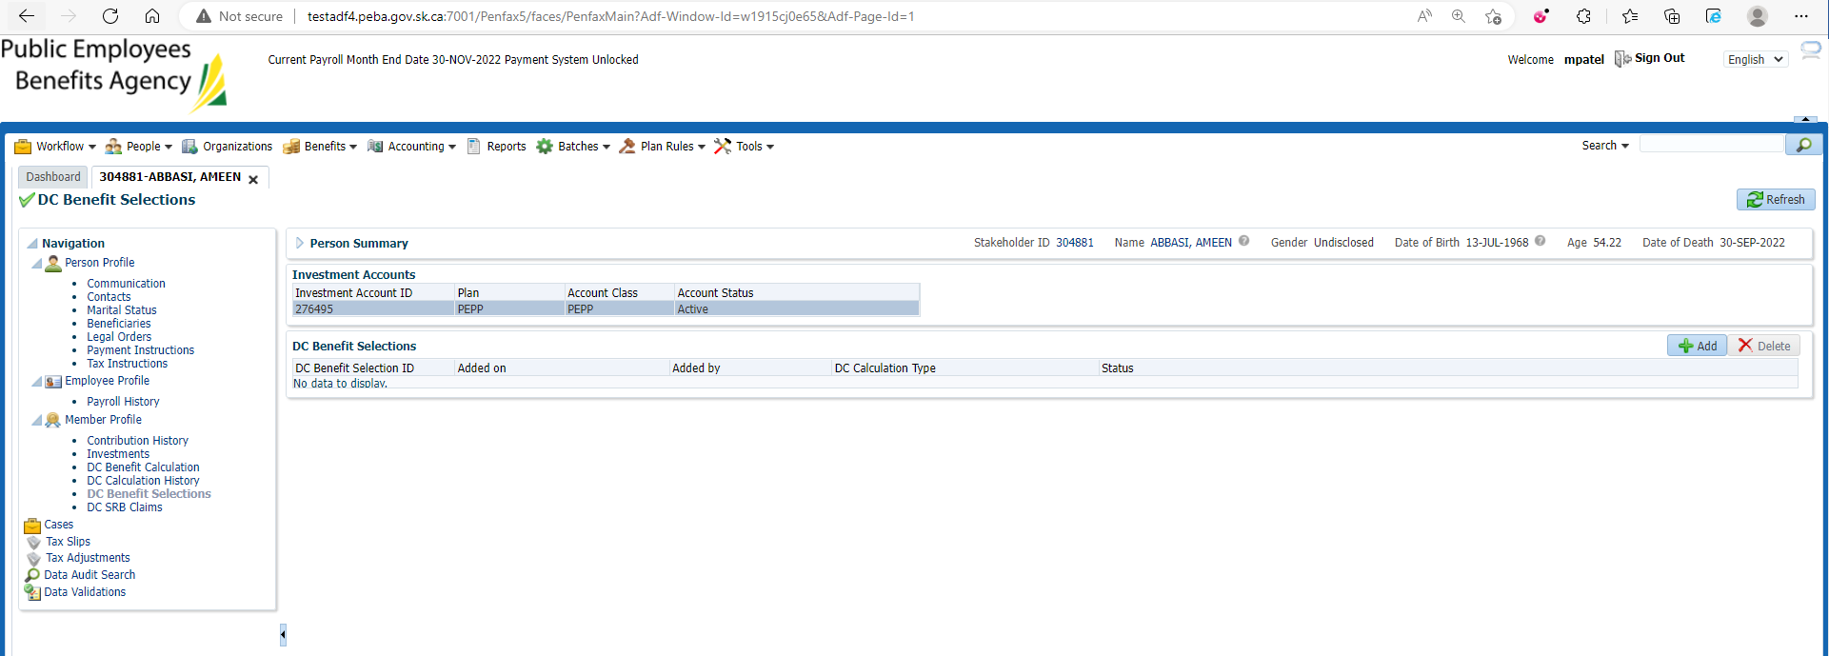

1. Verify Marital Status and Spouse Date of Birth and Death Date. Click Next.

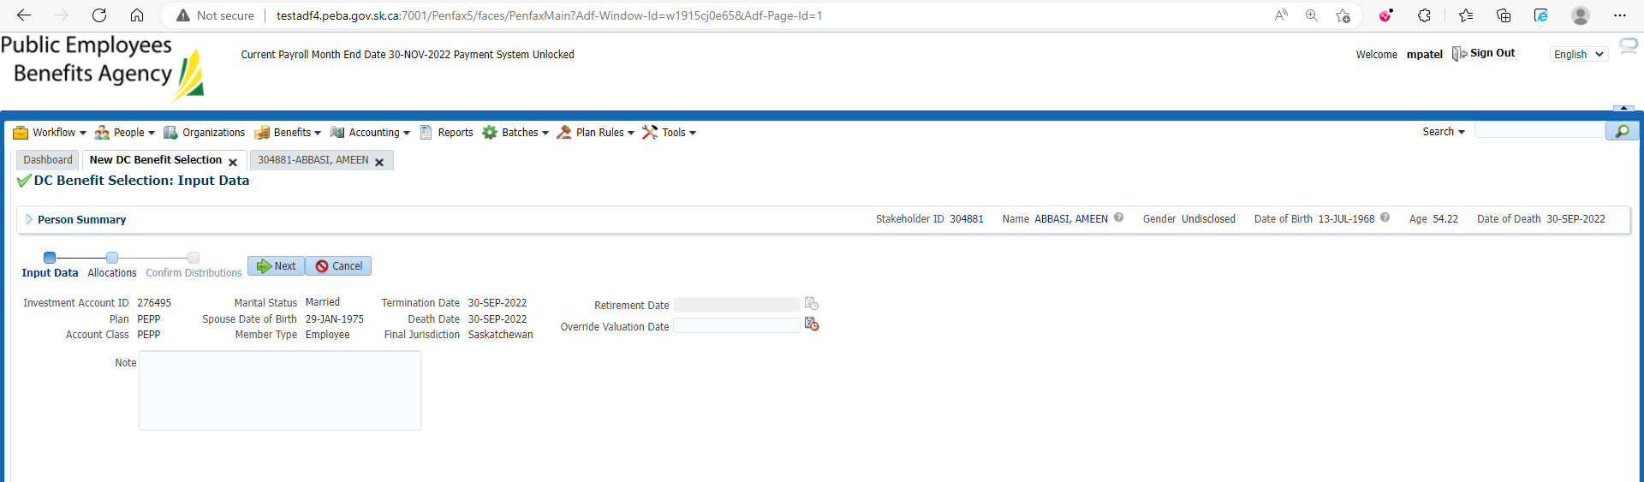

1. Click Add.

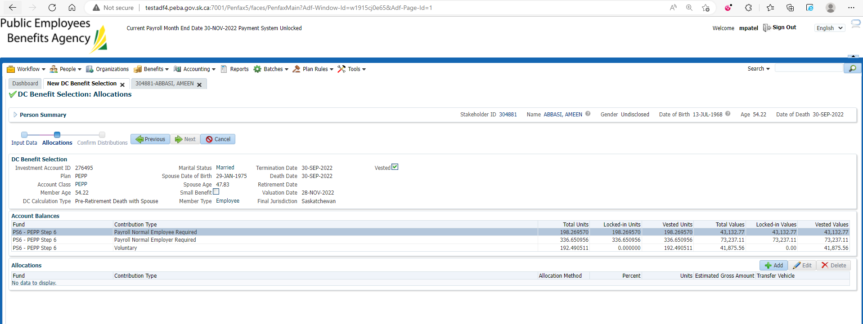

1. Select/input all the details and click on save. Repeat this for all the funds and all the contribution types.

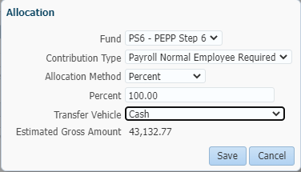

1. Once done, you can see all the records under Allocations. Click Next.

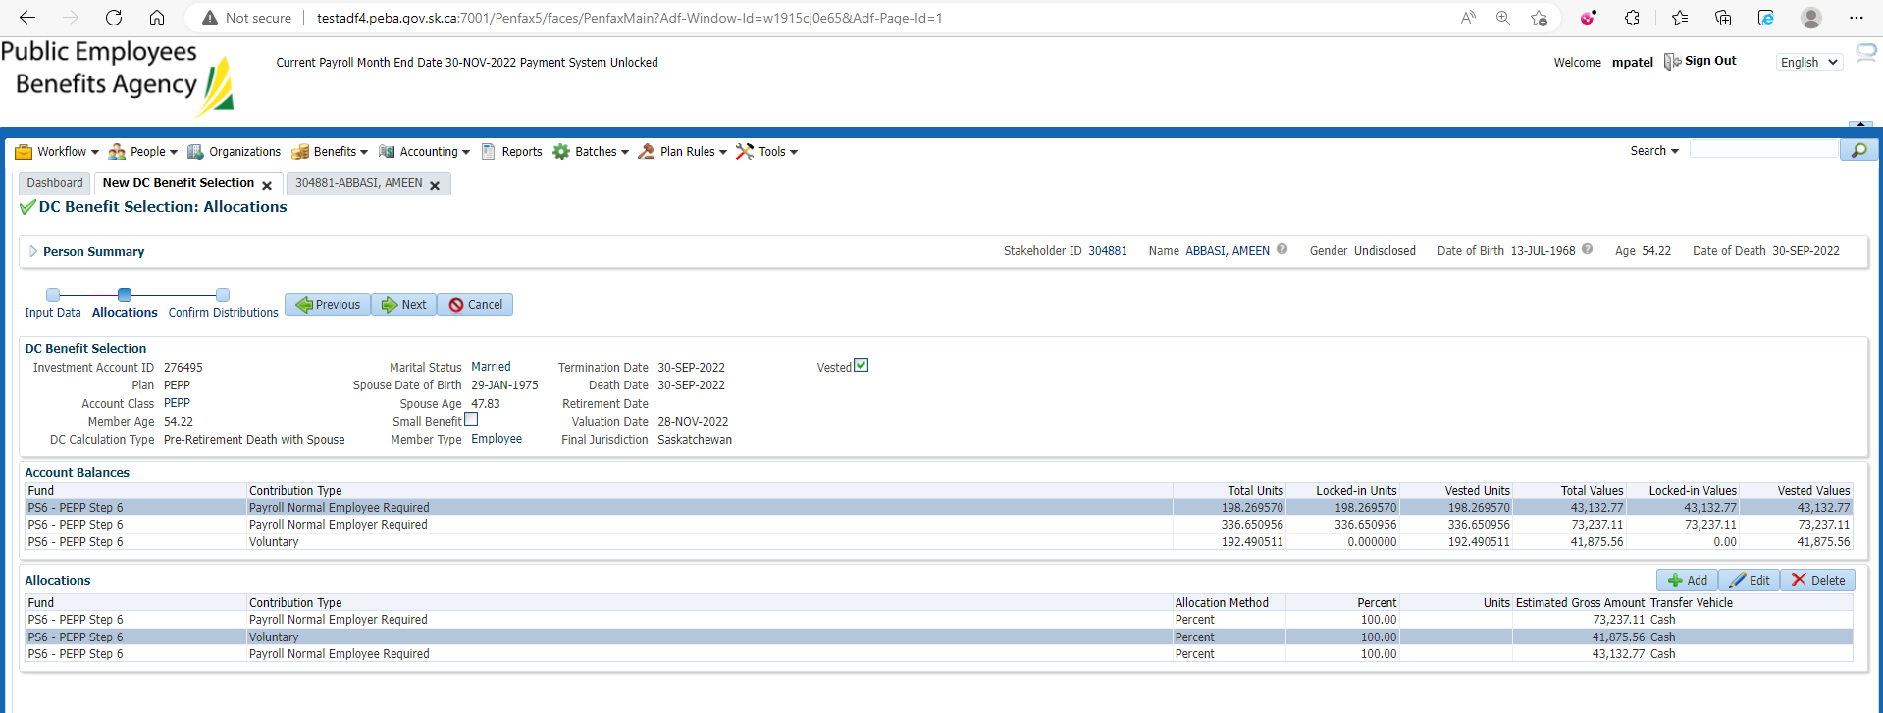

1. Verify the Recipients’ details.

You can add new Payment Instruction and Tax Instruction or you can use the existing saved one. Click Submit for Approval.

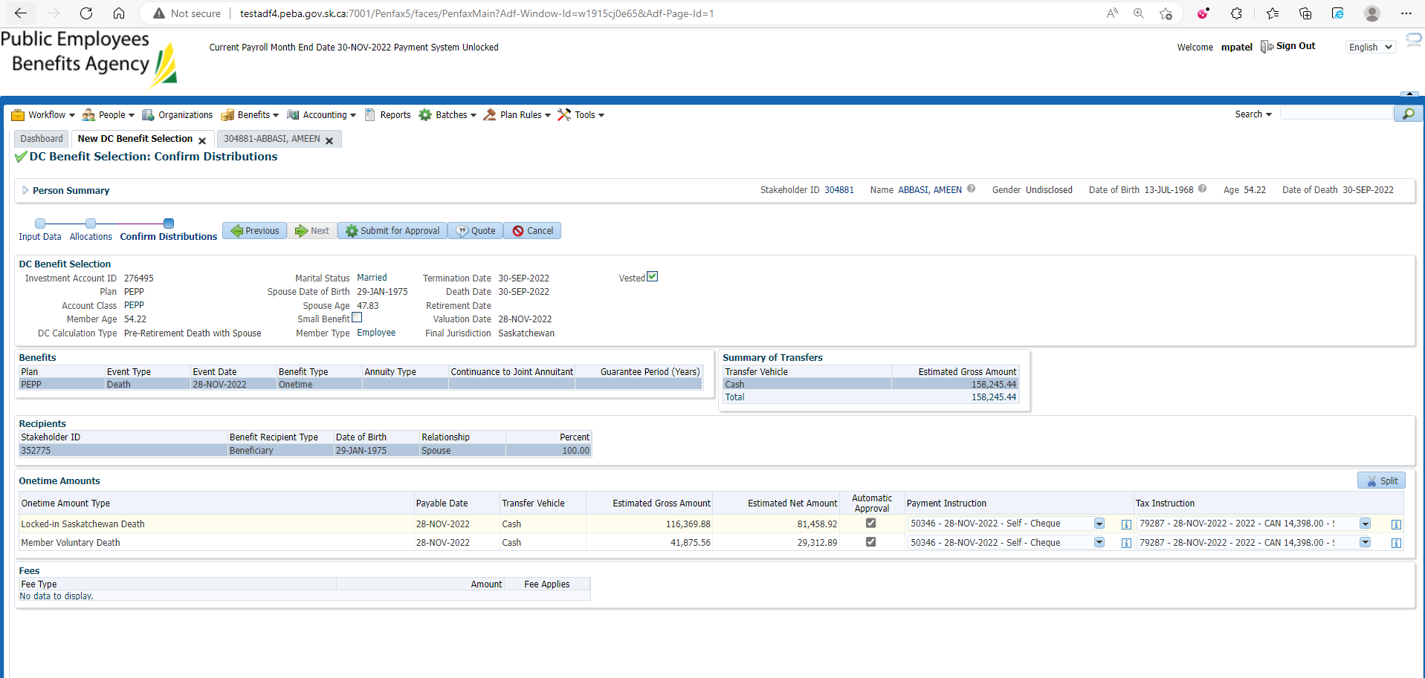

1. Verify all the details and click on Approve.

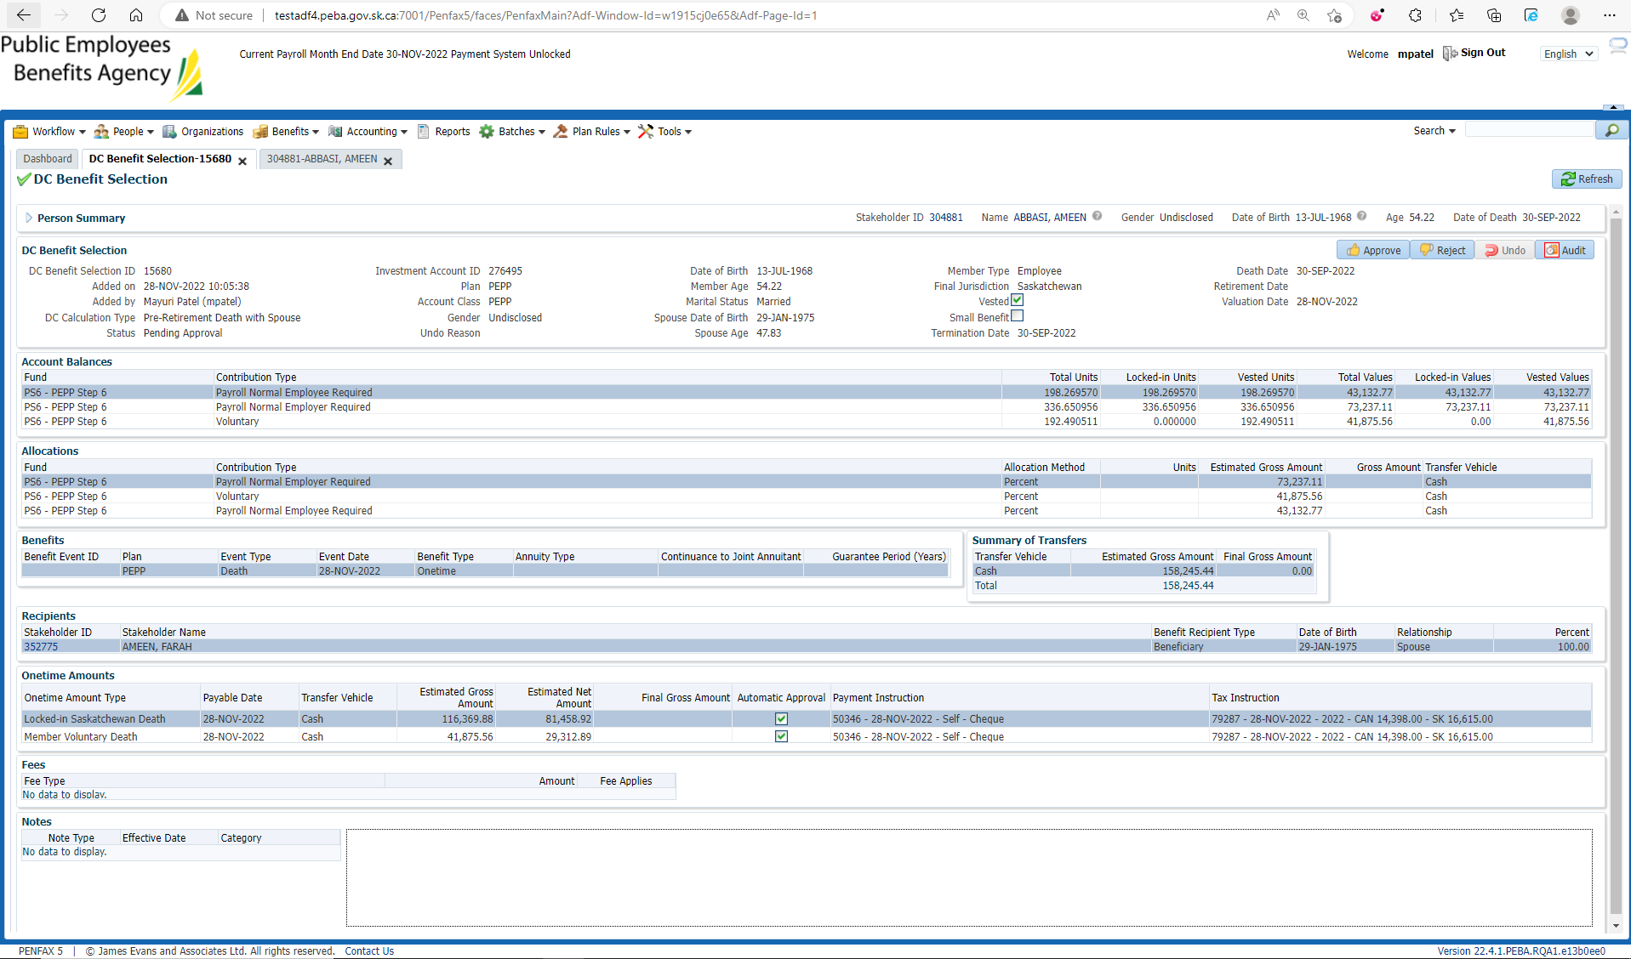

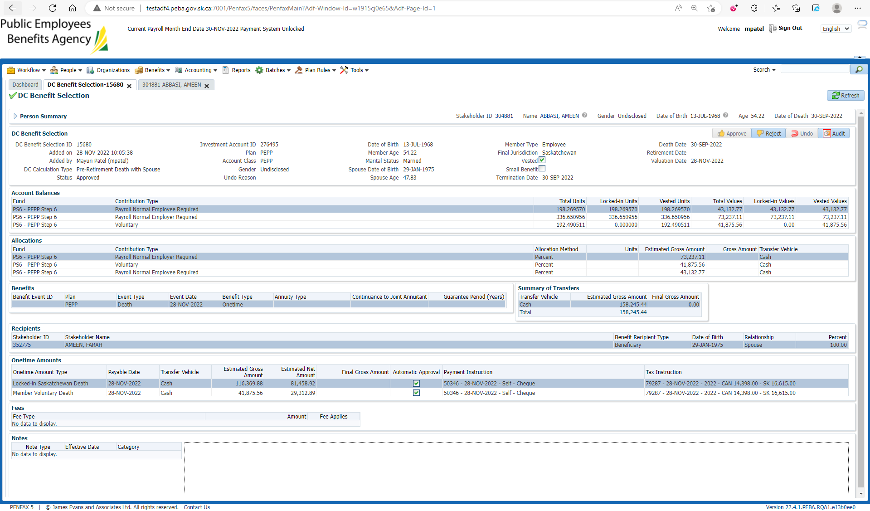

1. You can find the record of DC Benefit Selection under Member Profile -> DC Benefit Selections.

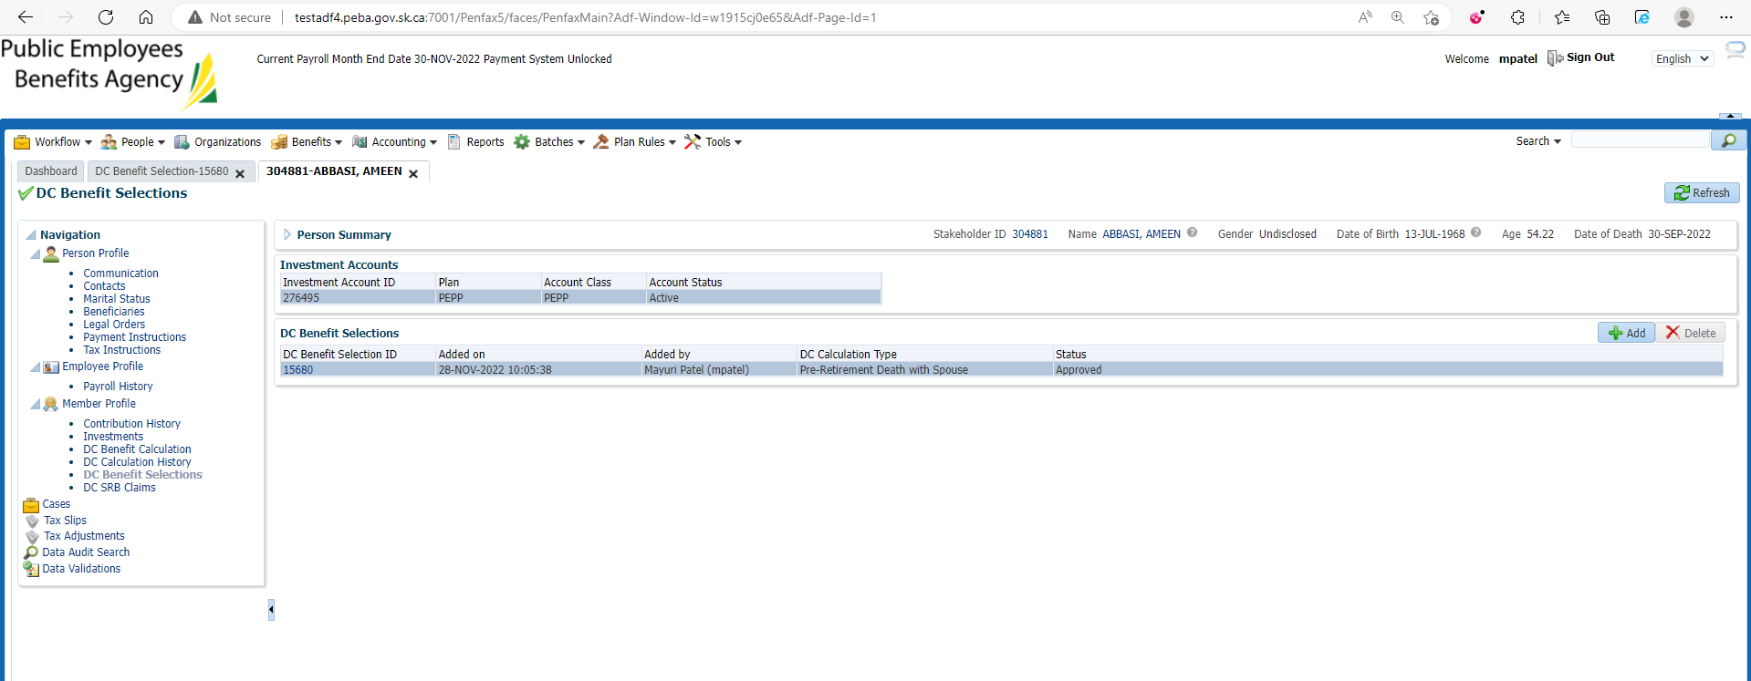

1. Wait for the overnight processes to run.

Bring up the Deceased Member again.

Click on Investments.

Make sure the account balance is now 0.

Make sure the Account status is Inactive.

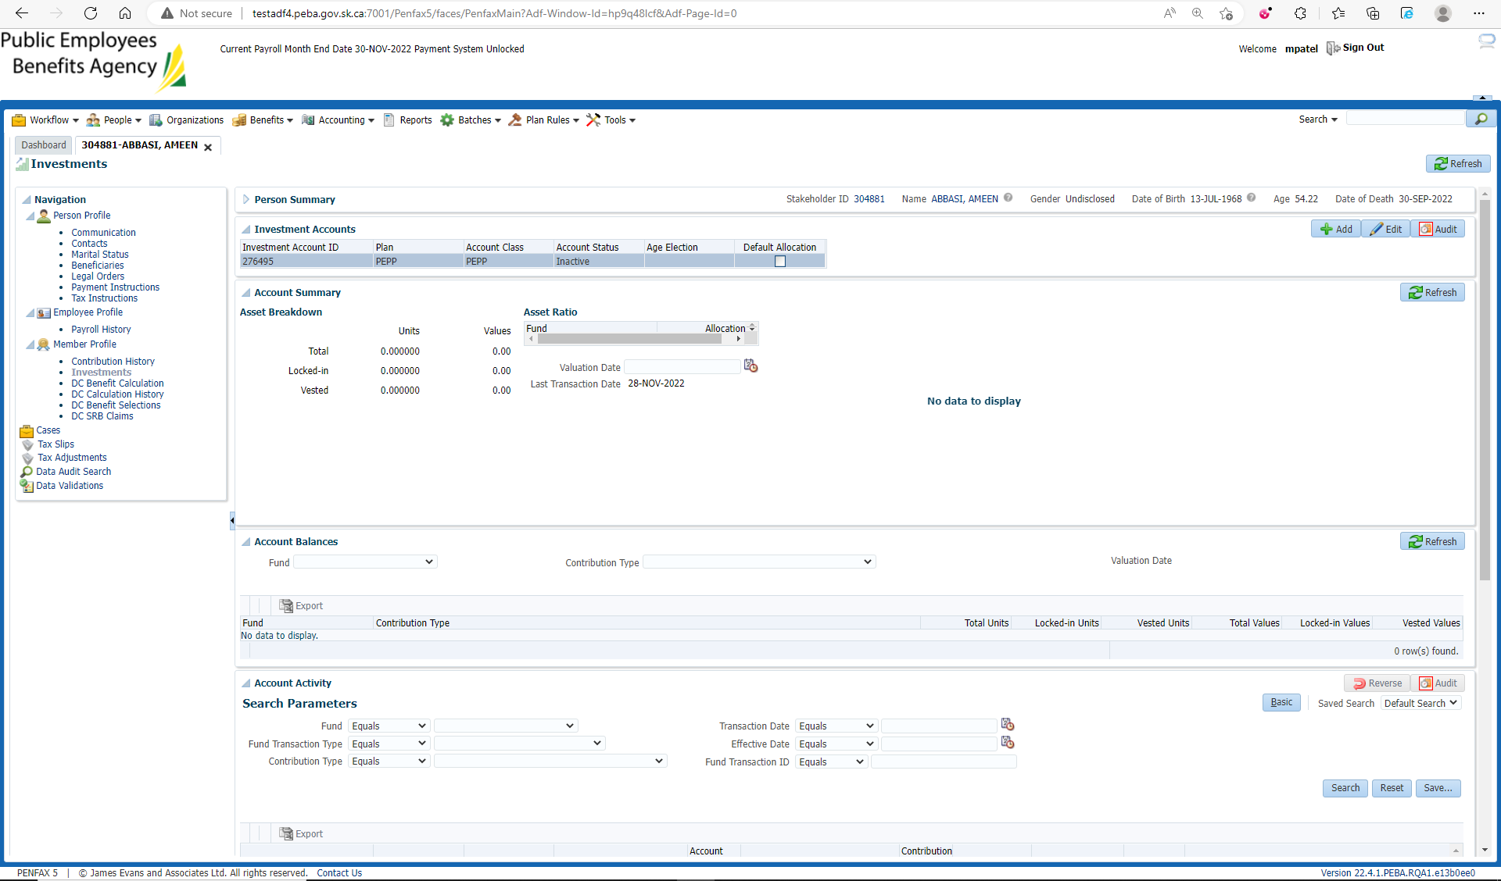

1. Go to Member profile. Make sure the Member status is Death.

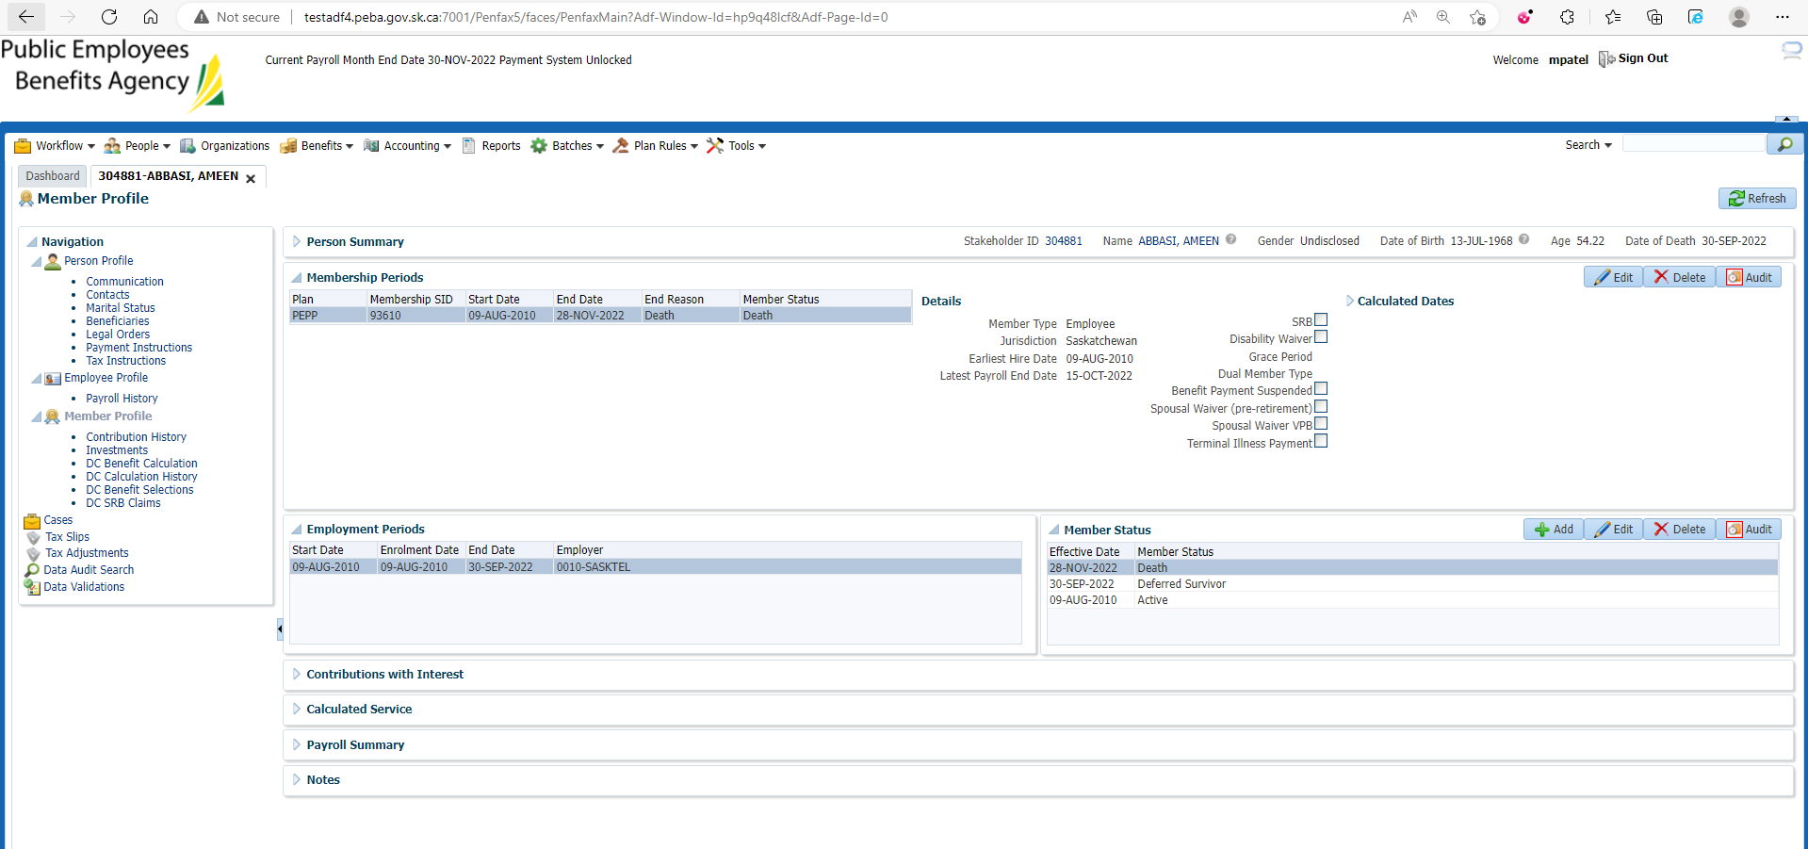

1. Bring up the Beneficiary stakeholder's account.

They should have a Benefit Recipient Tab available.

Open the benefit recipient tab.

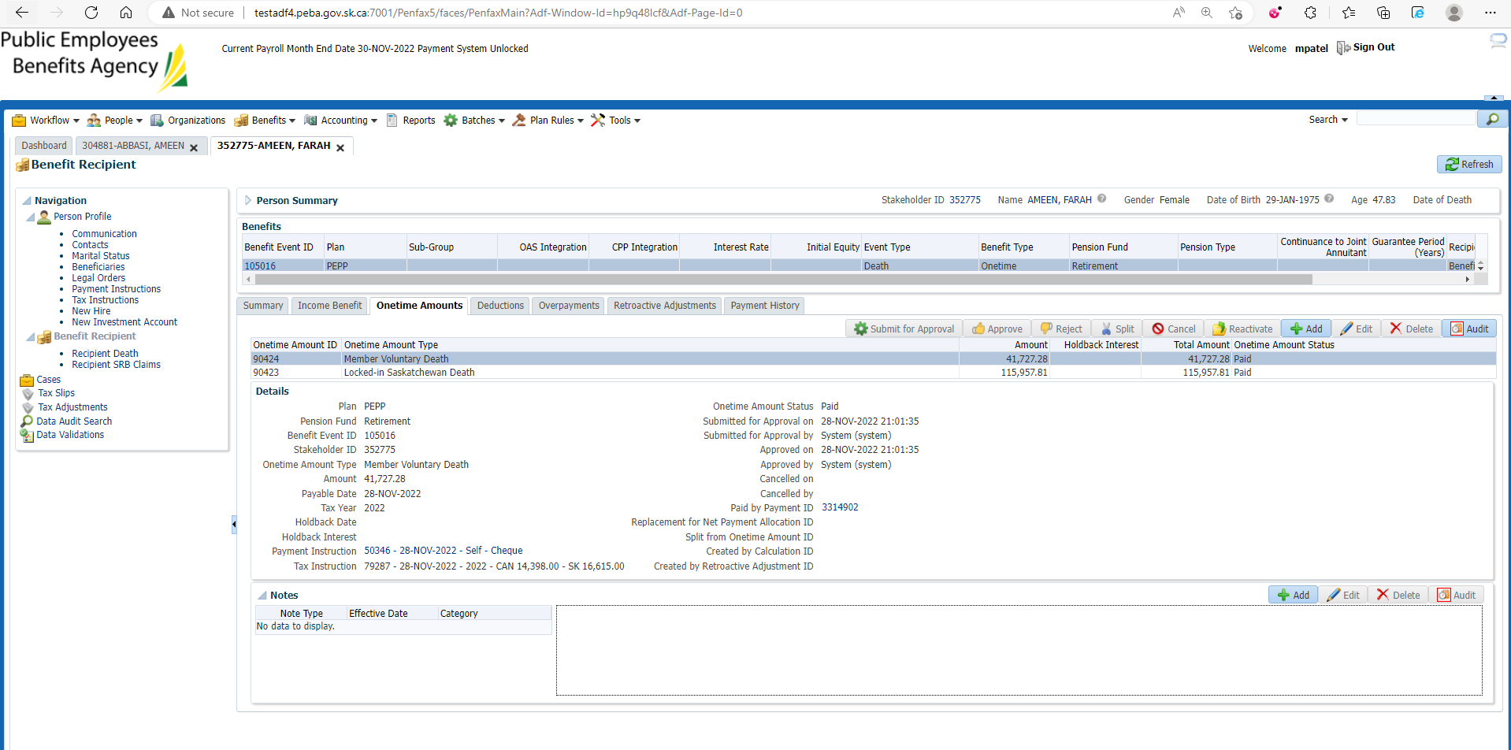

1. Click on Communication -> Outbound Documents. Letter for PEPP Payment to Non-Member is generated.

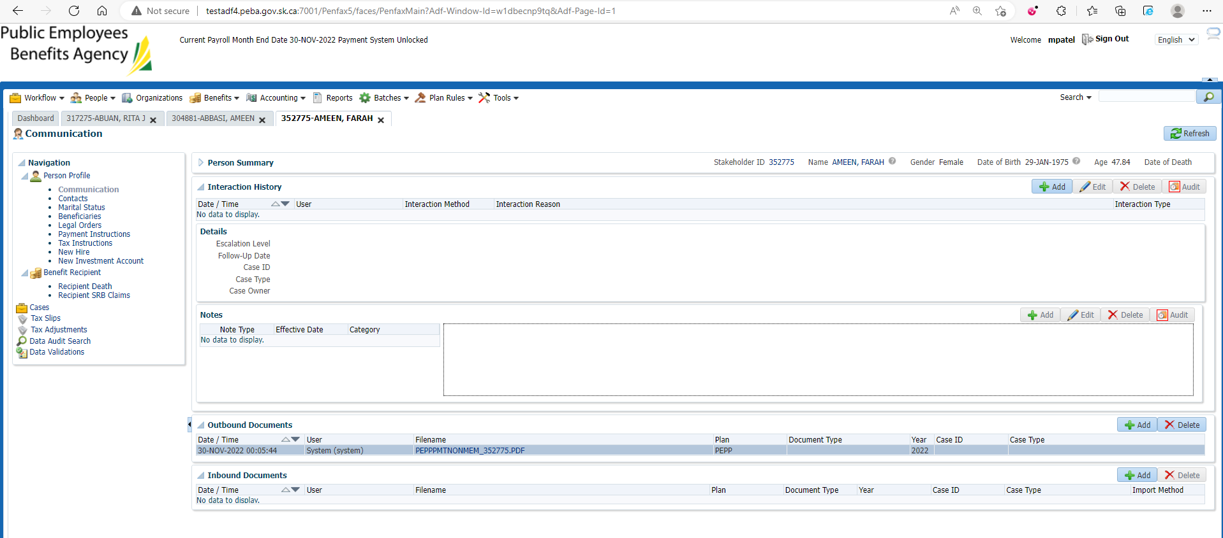

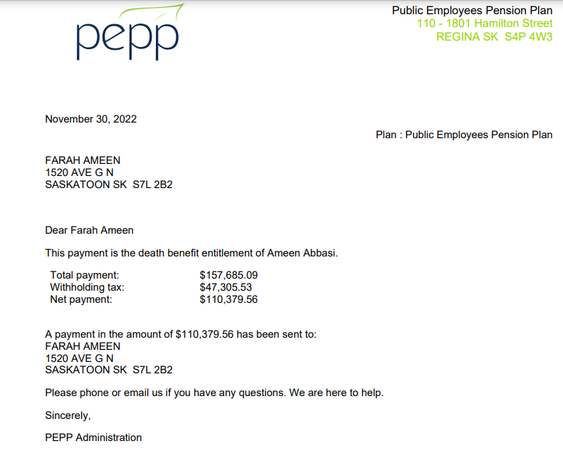

1. Click on Tax slips. There should be a Tax slip saved.

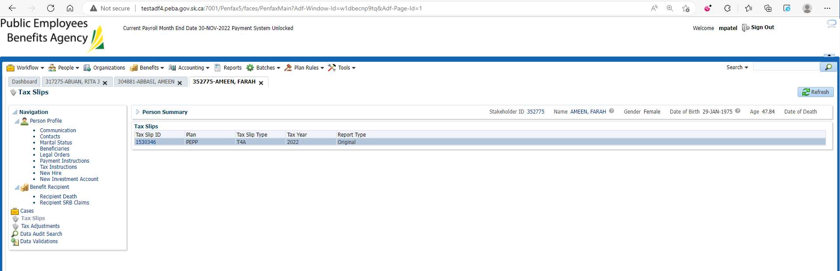

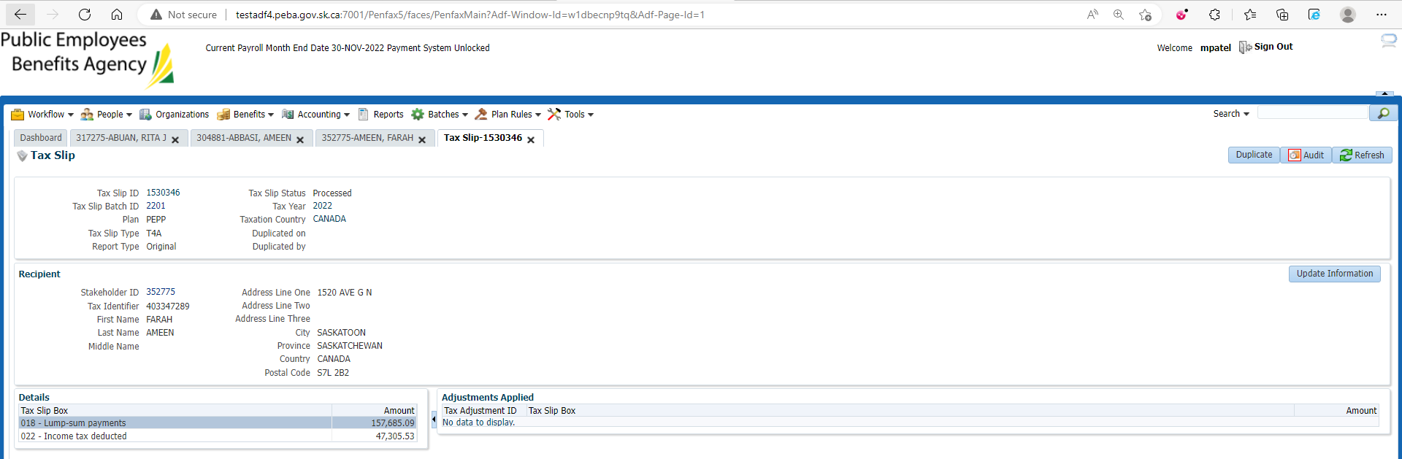

1. Go to Communication and you can see T4A generated there.

